July 25, 2025

Mike Kitlica
John Pompay
Cushman & Wakefield
2555 E Camelback Rd Ste 400
Phoenix, AZ 85016

RE: Proposal to Lease – 2844 W Deer Valley Rd

Mike and John,

On behalf of Uncle B’s House of Classics, I am pleased to submit the following lease proposal for your property located at 2844 W Deer Valley Rd. .

1. | Property Address: | 2844 W Deer Valley Rd, Phoenix, AZ 85027
2. | Landlord/Management: | AZ West Deer Valley LP
3. | Tenant: | Uncle B's House of Classics
4. | Premises SF: | +/- 16,052 SF
5. | Lease Term: | 64 months, first 2 months abated with the following 4 months at a rate of half the base rent.
6. | Lease Commencement: | August 1, 2025
7. | Rental Rate: | $1.40/psf NNN
8. | Operating Expenses: | Please confirm current operating expenses.
9. | Tenant Improvements: | None
10. | Building Systems: | Landlord will deliver all HVAC, EVAP, mechanical, electrical, lighting, plumbing, life safety systems and overhead door equipment serving the Premises in good and working order.
12. | Signage: | Tenant shall have signage rights for the building commensurate with its proportionate share of the Building at Tenant’s sole cost and with Landlord’s reasonable approval and per City of Phoenix sign code requirements.
13. | Security Deposit: | Security Deposit shall be equal to last month’s rent.
14. | Real Estate Commission: | In the event the Tenant leases the Premises, DAUM Commercial Real Estate Services (Lundstedt/Heinemann) shall be paid a commission of 5% at lease execution.
This proposal is not intended and does not constitute, a binding agreement by any party, or an agreement by any party to enter into a binding agreement. It is merely intended to specify some of the proposed terms and conditions of the transaction contemplated herein to facilitate reaching a final agreement in the form of an executed lease.

Thank you in advance for your consideration and please feel free to call with any questions.

Signatures on following page

Sincerely,
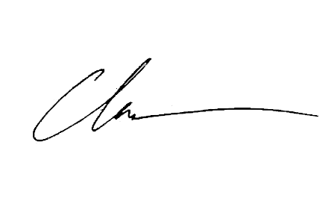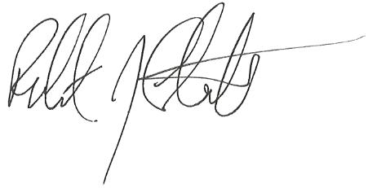
Chase Heinemann Robert Lundstedt
DAUM Commercial Real Estate DAUM Commercial Real Estate
cheinemann@daumcre.com rlundstedt@daumcre.com
(602) 689-4071 (602) 363-7238

AGREED AND ACCEPTED:

 | LANDLORD: | AZ West Deer Valley LP
By:
Its:
Date:

