Non-Binding Letter of Intent to Lease Space

Deer Valley Technology Park
Building B
2837 West Louise Drive Phoenix, Arizona

Prepared for:



December 7, 2024

Prepared by:

Michael Kitlica
Senior Director
T 602-468-8559
F 602-468-8588
Michael.Kitlica@cushwake.com

December 7, 2024

Spencer Gray
New Market Advisors Commercial Real Estate
5245 South Durango Drive
Las Vegas, Nevada 89113

RE: Proposal – Caliber Collision at Deer Valley Technology Park

Spencer:

Cushman & Wakefield, on behalf of Hopewell Development (hereinafter “Landlord”), is pleased to present this non-binding proposal to Caliber Collision (hereinafter “Tenant”) to lease industrial space within the project.

Ownership: | Hopewell Development
Building Name & Address: | The Premises shall be located within Building B of Deer Valley Technology Park located 2837 West Louise Drive Phoenix, Arizona
Proposed Premises: | Approximately 43,562 rentable square feet (“RSF”), located on the first (1st) floor of building.  The building is measured per BOMA 2024 standards. The Premises is shown on Exhibit A attached to this letter. There is no load factor for this asset.
Commencement Date: | June 1, 2025.
Early Fixturization: | Tenant shall be permitted to have fifteen (15) days of early occupancy within the Premises prior to the Lease Commencement date (the “Early Occupancy Period”) for installation of furniture, fixtures and equipment at no charge. Tenant’s early occupancy shall not interfere with Tenant Improvement construction.
Common Area Access and Parking: | Please see the attached brochure for Tenant’s secured parking/yard access overview.
Lease Term: | Fifteen (15) Years  Months 01 -06: $0.00 per RSF/month, NNN*  Months 07- 12: $1.30 per RSF/month, NNN*  *Plus annual Three Percent (3%) increases thereafter  **Plus applicable sales tax
Operating Expenses & Real Property Taxes: | Tenant shall be responsible for its pro rata share of real estate taxes, insurance, and common area maintenance.
Tenant Improvement Allowance: | Landlord will provide turnkey tenant improvements which shall include but not limited to:  - Enhanced interior premises lighting  - Constructing a secured yard  Tenant Improvements costs shall not exceed One Hundred Thousand Dollars ($100,000).
Building/HVAC Hours: | Available 24 hours a day, 365 days a year.
Tenant Identification: | Tenant, at Tenant’s sole cost and expense, shall have the right to interior suite and building signage (east, west and south facing) subject to landlord’s reasonable approval and City of Phoenix signage code and regulations.
Assignment & Subletting: | Landlord shall grant Tenant the right to sublease or assign all or a portion of the Premises throughout the term of the lease with Landlord's consent, which shall not be unreasonably withheld.

Renewal Option: | Landlord will grant Tenant two (2) five (5) year options to renew its lease for all of the Premises with at least twelve (12) months prior written notice to Landlord. The rental rate for the renewal term would be calculated at then stated market rents.
Holdover: | Tenant shall pay rent during any holdover period equal to during the first two months, 125% of the monthly rental last in effect under lease and thereafter 150% of such amount.
Parking: | Ninety (90) parking stalls
Security Deposit: | Waived, subject to Landlord’s review and approval of Tenant’s financial statements.
Access: | Tenant requires access 24 hours per day, 7 days per week on the Premises.
Corporate Guarantee: | This proposal is predicated on Caliber Collision’s parent company as the guarantor.
No Relocation: | There will be no relocation clause within the lease.
Zoning: | This proposal and use is subject to a (C-3) zoning change, which may involve a Special Use Permit or a re-zone of this building.
Brokerage: | Landlord and Tenant acknowledges that New Market Advisors Commercial Real Estate shall represent the Tenant’s interest in this transaction. Landlord has agreed to pay a commission to the Tenant’s Broker, Spencer Gray of New Market Advisors Five Percent (5%) of the total lease consideration for the first five (5) years and Two-Point Five Percent (2.5%) for years 6 through 10 and One-Point Five Percent (1.5%) for the remaining lease term, payable Fifty Percent (50%) upon execution and Fifty Percent (50%) occupancy. Landlord and Tenant shall indemnify each other from any other claim for a commission resulting from this lease transaction.
Confidentiality: | It is understood that the contents of this proposal will be held in the strictest confidence and that the above parties will not disclose this information without prior written consent by all parties.

This proposal is not intended to bind Landlord or Tenant in any way. Rather, this proposal is an expression of the basis upon which Landlord would consider entering into a lease for the Premises and to serve as a guide for the preparation of a definitive lease. This proposal is made subject to correction of errors, omissions, prior lease, change of price or terms, or withdrawal from market without notice. No liability or binding obligation is intended to be created between Landlord and Tenant and any legal rights and obligations between Landlord and Tenant will come into existence only upon the execution and delivery of a definitive lease acceptable in form and content to Landlord and Tenant (and then only in accordance with the provisions of the definitive lease) and upon Landlord’s approval of Tenant’s financial condition. The terms of this proposal will expire on December 17th, 2024.

We look forward to receiving a favorable response from your client. Please feel free to contact me at (602) 469-8559, if you have any questions or if I can provide any additional information.

Best regards,

Michael A. Kitlica
Senior Vice President
michael.kitlica@cushwake.com

TENANT:

Caliber Collision

By: _____________________________

Its: _____________________________

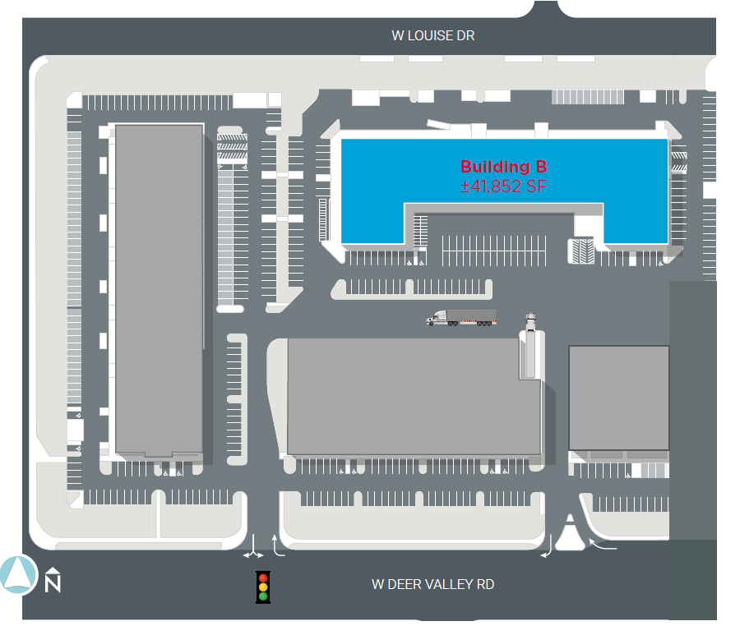
Fenced Yard

